GDD “A warring State” – Game Design Elective

Umberto Falkenhagen

Executive summary

It’s the Sengoku Jidai – the period of warring states. It’s a time of civil war in Japan and the time we mostly think of when imagining Samurais and Ninjas. A time where the fate of once mighty clans can change within days, a time of great self-sacrifices and bravery but also of treachery and betrayal.

The protagonist is a warrior, who serves the local lord Tokugawa Ieyasu. In that role he must carry out certain missions and help his lord to rise in power. While being raised as a law-abiding person, who takes it as an honour to serve the higher ranked classes, he soon starts to see the world through a different angle. Even though his/her lord promises much gain from the missions, he will soon see that everything has its price and become entangled in the chaos of war and unravel that his lord though seemingly kind might not be the righteous and honorable person he/she wants to follow.

* The game aims to give the player a feeling of disturbances of war. The goal is to have the player emersed in a way that they have to make tough decisions and think of what is best for them and what is best for the country.
* Story-heavy, focused on the rising of Ieyasu Tokugawa (future Shogun (ruler) of Japan.
* Meant to show the consequences of war for the people.
  + E.g. Losing family members, homes destroyed

Gameplay

* Core Gameplay: Stealth and Souls-like with using a card-deck for abilities.
* Top-Down strategy (similar to games like Desperados)
* Playing as a ninja, the goal is to get through the levels without being seen.

External Goals:

* Creating a portfolio piece
* Creating an interesting mix of strategy and souls-like elements
* Advance level- & game-design knowledge
* Getting better with Unity

Internal Goals:

* Motivate user to use different strategies for different levels
* Give the player a feeling of control (equipping cards and items) while not making the level “predictable” (through the random factor of drawing the cards)

Gameplay Goals:

* Player creates a character that is adjusted to personal interests (e.g. fighting style)
* Player has to find a delicate balance between offensive and defensive abilities

Mechanics

* Before the mission starts, the player builds a deck out of different abilities. By choosing the amount of each chosen ability card in the deck, the player decides how often it can used throughout a mission (kind of an inventory) and also how likely it is to draw the card with each draw.
* Levels are played in a somewhat turn-based system, meaning that the player can choose a few cards per turn and draw new cards once he has used all chosen cards from the last turn.
* When the mission first starts, the player can move around the level in real-time using normal controls and a range of ‘always available actions’ (like climbing onto something, running, sneaking, etc.). To use his priorly chosen abilities however, the player has to start the first ‘turn’.
* Each ‘turn’ starts with a random selection of cards drawn from the players deck (e.g. 10 different cards). The player chooses a number of cards from the selection up to a defined limit of (e.g. up to 4 cards) that fit what he’s planning to do within the upcoming turn. If the cards do not match, he can redraw once, if the new selection still does not fit his plans, he can redraw again multiple times but the total amount of additional redraws throughout the mission is limited, depending on the difficulty settings (chosen by the player) and the mission (chosen by the developer (me)). Throughout this whole process the game is paused
* The player is then able to move through the level in real-time, using normal controls, a range of ‘always available actions’ (like climbing onto something, running, sneaking, etc.) and finally the chosen abilities. NPCs will follow different movement patterns and activities. The player has to observe what they are doing and decide when to use the abilities properly.

Game Elements

Worldbuilding, story, characters, locations, level design, etc.

Assets

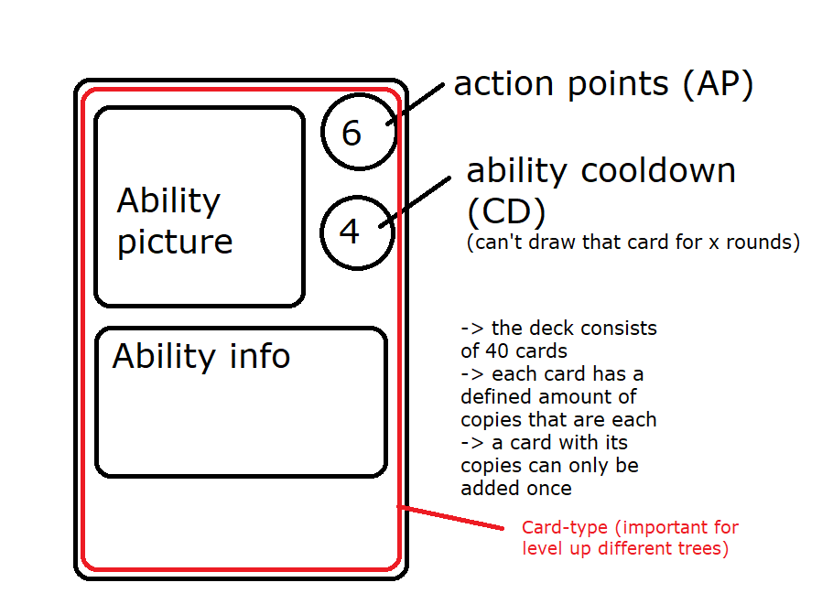Music, sounds effects, 2D/3D models, etc.

Inspirations/Sources

Inspired by:

Divinity Original Sin I/II

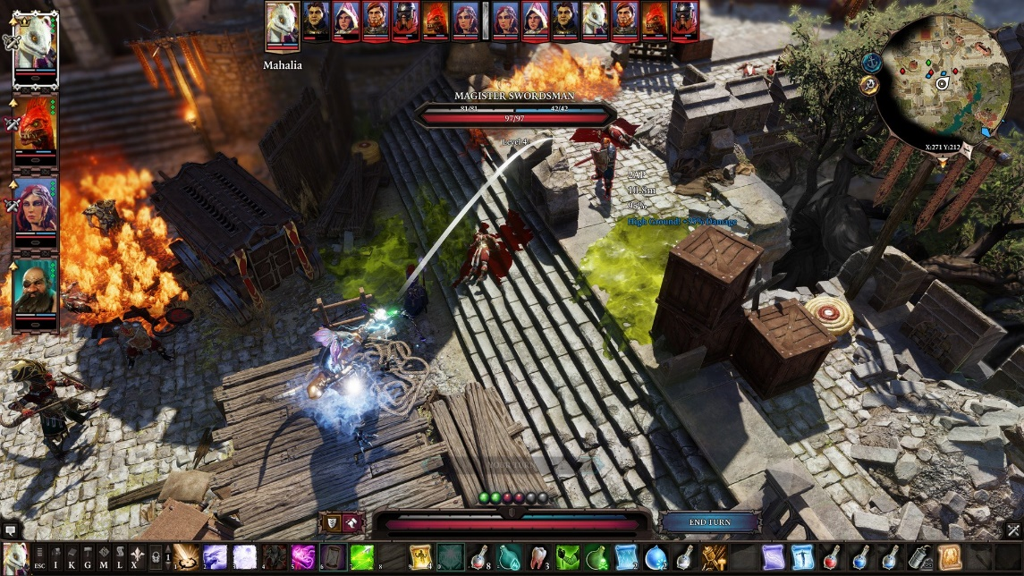

Desperados (III)

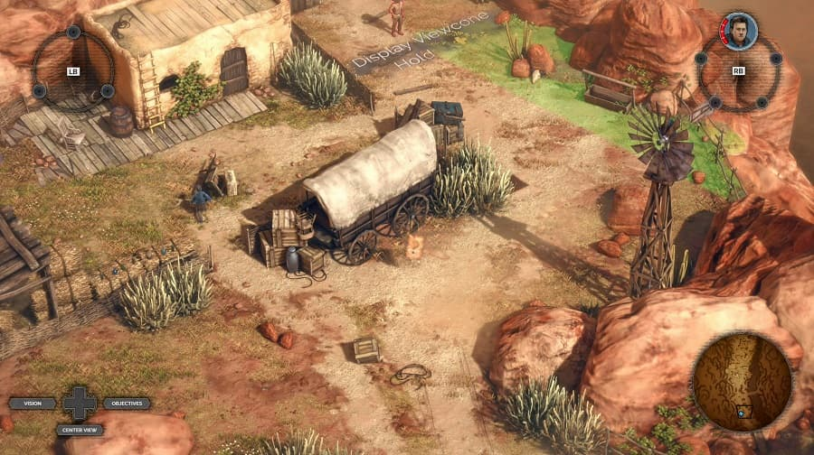

Game Design Elective – One-Pager

**Game Title:** “A warring State”

**Game System:** PC for now, though the concept is not platform-bound.

**Target audience:** 16+ years old; fans of small-group strategy like Divinity Original Sin, Desperados, Gears Tactics, XCOM; fans of Japanese history

**User experience:** Since the game focusses on one character and its development the user experience should be designed in a way that gives a good overview over the functions. While being within a level the UI is kept simple, consisting of the available actions, action points and character infos (health etc.). The look will be ‘dark’. This relates to the atmosphere and setting of the game which is set within the civil war and describes the period of the Sengoku Jidai – the period of warring states.

**Genre:** Stealth/Souls-likeround-based strategy game with a top-down perspective and that mixes parts of a card-game into the experience

**Story summary:** It’s the Sengoku Jidai – the period of warring states. It’s a time of civil war in Japan and the time we mostly think of when imagining Samurais and Ninjas. A time where the fate of once mighty clans can change within days, a time of great self-sacrifices and bravery but also of treachery and betrayal.

The protagonist is a warrior, who serves the local lord Tokugawa Ieyasu. In that role he must carry out certain missions and help his lord to rise in power. While being raised as a law-abiding person, who takes it as an honour to serve the higher ranked classes, he soon starts to see the world through a different angle. Even though his/her lord promises much gain from the missions, he will soon see that everything has its price and become entangled in the chaos of war and unravel that his lord though seemingly kind might not be the righteous and honorable person he/she wants to follow.

**USPs**:

* combination of Card-game- and RPG-elements
* interesting piece of japan history that is a great part of japanese ‘legends’
* interesting mechanics when it comes to choosing equipment and cards (e.g. gathering famous equipment makes you more recognizable which demotivates weaker enemies but makes stronger enemies more eager to kill you for fame)

**Similar Games:**

* + - Divinity Original Sin
    - Desperados
    - XCOM
    - Gears Tactics
    - Shogun Total War (Art-style-wise)
    - **Shadow Tactics**
    - **Hitman**

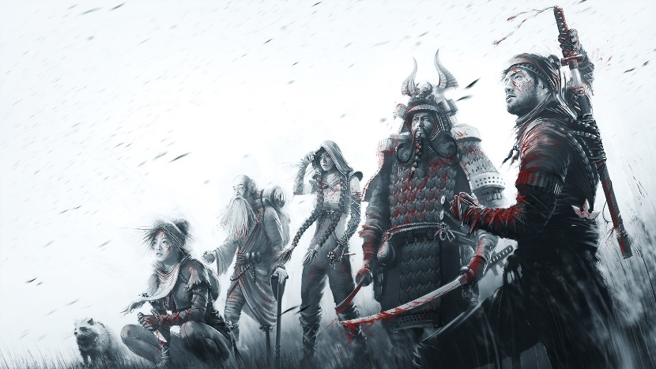**Moodboard**

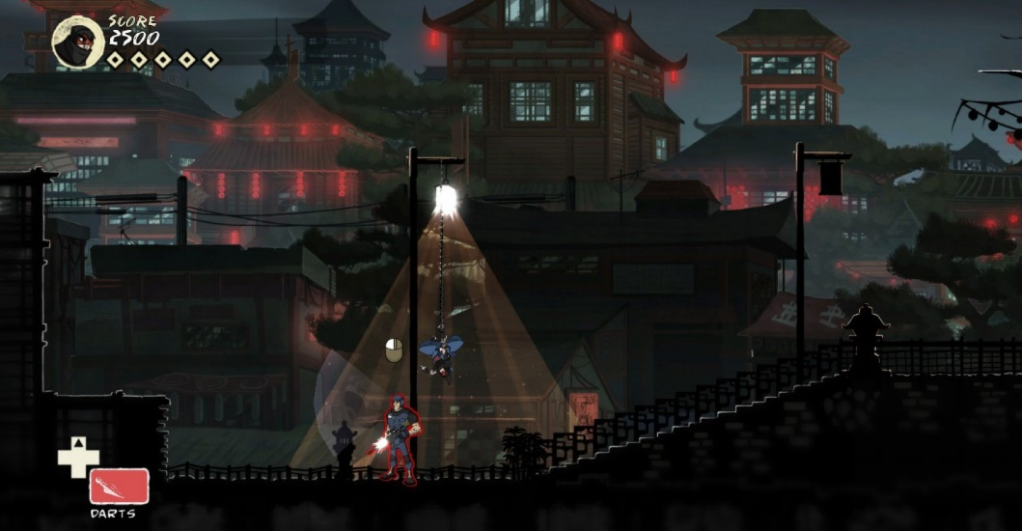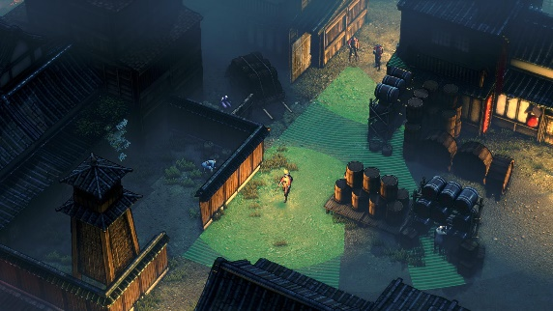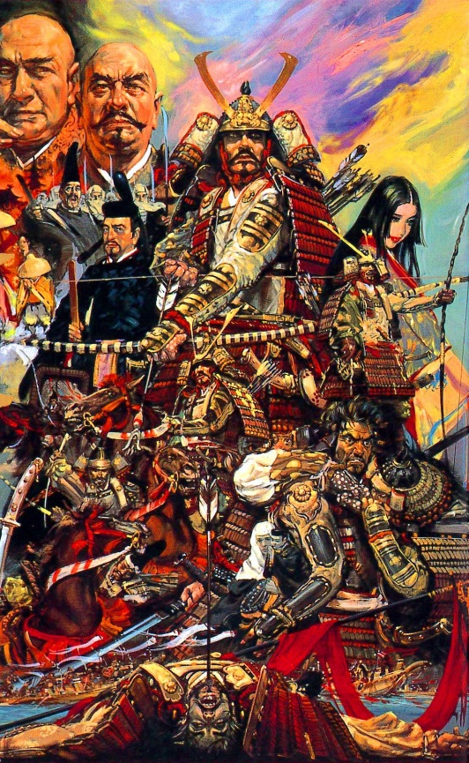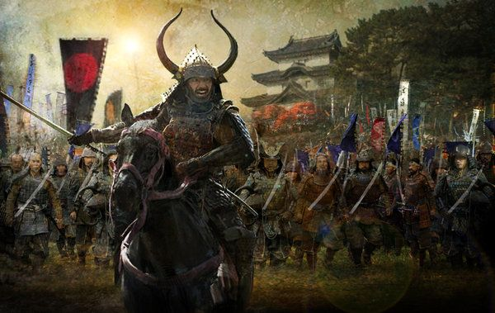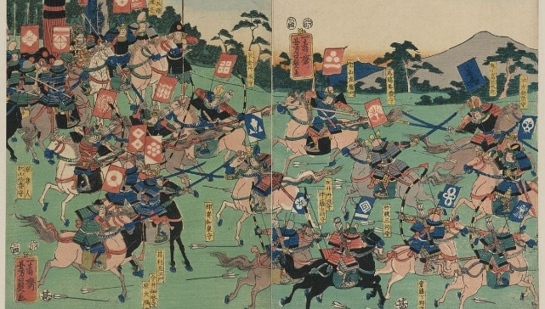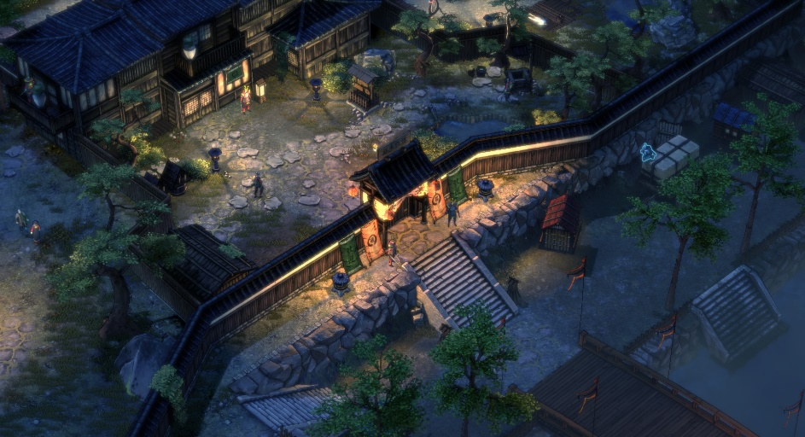**Structure**

* Linear story that is visualized by different levels, that depict certain aspects of the story, e.g. free a relevant character, assassinate an important enemy
* Levels are semi-linear as the game offers different options to deal with the obstacles, e.g. killing an enemy or sneaking around them
* There are priorly defined ways through the level though the outcome of the level is always the same

**Possible level structure:**

Level Start 🡪 Cutscene for Enemy Encounter 🡪 Puzzle to open next door 🡪 Find way to kill or sneak around enemies 🡪 Achieve Quest-goal 🡪 Sneak back outside 🡪 Level End

## Rewarding the player

social reward works for my game as the player is mostly on their own throughout the levels but are able to discuss what happened when back in their base

rewarding the player with exploring as the might unlock easier ways to achieve the final goal of the level by finding additional information

rewarding the player with abilities that supplement their favored play-style

## Puzzles

pattern recognition as the players have to recognize how the enemies move around the level

abstracting, cause there are different ways to reach the goal

and also lateral thinking because they can make their own rules by choosing what skills they use to get through the level